✴

**Document an existing experience**

**TIP**

As you add steps to the experience, move each these “Five Es” the left or right depending on the scenario you are documenting.

Narrow your focus to a specific scenario or process within an existing product or service. In the **Steps** row, document the step-by-step process someone typically experiences, then add detail to each of the other rows.

Customer experience journey map

|  |  |  |  |  |  |
| --- | --- | --- | --- | --- | --- |
| **SCENARIO**  **Browsing, booking, attending, and rating a local city tour** | **Entice**  How does someone initially become aware of this process? | **Enter**  What do people experience as they begin the process? | **Engage**  In the core moments in the process, what happens? | **Exit**  What do people typically experience  as the process finishes? | **Extend**  What happens after the experience is over? |
| **Steps**  What does the person (or group) typically experience? | **LOGIN**  Open portal Login using If new user create an credencial account | **Visualization**  User can visualize different statistical charts | **ANALYSIS AND INTERPRETATION**  User can analyze and interpret useful insights through visualization | **THANK YOU FEEDBACK**  **LETTERS SURVEYS**  One effective way to Feedback surveys are sent  build customer rapport after a purchase and they  is by following up with a evaluate the customer's  thank you letter experience with our product or service | customer contact Real time information |
| **Interactions**  What interactions do they have at each step along the way?  **People:** Who do they see or talk to?  **Places:** Where are they?  **Things:** What digital touchpoints or physical objects would they use? | Creating relevant product  Through association allow customers  advertisements to find products that are related to other products they  are purchasing | Free trail landing Connect through page google account | They are mostly interacted with QUESTIONARIRE  SURVEY in the farmers market    They interact with The most important  products or services, customer jobs are  gain creaters, pain identified as stocking  upon fresh and healthy  relivers food | Traditional Media, Social media, Word of mouth | It will be used to Agri-Business is the most detect the growth of important and Major the agriculture in the sector of any national  economy especially in  country india |
| **Goals & motivations**  At each step, what is a person’s primary goal or motivation? (“Help me...” or “Help me avoid...”) | Help me for [ Goal or  Scheduling motivation ] | Help me for user Help me for better friendly customer service | Help me for Help me for creating  accurate expense free trail landing page  tracking and visualization  templates | Help me for creating Help me for creating Help me for creating training interface account setting help center materials | Help me for better  profitability Help me for higher productivity |
| **Positive moments**  What steps does a typical person find enjoyable, productive, fun, motivating, delightful, or exciting? | The customers are happy if it is user friendly | The customers are happy If the Visualization is easy and clear to understand | The customers are happy if the insights useful and informative through analysis | The struggle with the water insufficient or heavy rainfall | Environmental  poor factors are the  infrastructure most important  and decrease factors that  of soil fertility affect the growth of crops |
| **Negative moments**  What steps does a typical person find frustrating, confusing, angering, costly, or time-consuming? | Invalid credentials Delay in Verification | Problem in understanding the visualization | Problem in presenting useful & required insights to the user for analysis and interpretation | save money Consume loyalty | Ensure greater satisfaction |
| **Areas of opportunity**  How might we make each step better? What ideas do we have? What have others suggested? | Increase the crop Improve Advertising Increase Customer value | Make Verification By visualizing the Increase quality Process much easier results the user can  and simple easily predict the  crop production | Updating the Updating the  policies database | The user interfce can be improved | Improve the food safety |

Use this framework to better understand customer needs, motivations, and obstacles by illustrating a key scenario or process from start to finish.



When possible, use this map to document and summarize interviews and observations with real people rather than relying on your hunches or assumptions.



Created in partnership with

[**Share template feedback**](https://muralco.typeform.com/to/CiqaHVat?typeform-source=app.mural.co)



**Need some inspiration?**

|  |  |  |  |  |  |  |  |  |
| --- | --- | --- | --- | --- | --- | --- | --- | --- |
|  |  |  |  |  |  |  |  |  |
|  |  |  |  | |  |  |  |  |

|  |  |  |  |  |  |  |  |  |
| --- | --- | --- | --- | --- | --- | --- | --- | --- |
|  |  |  |  |  |  |  |  |  |
|  |  |  |  | |  |  |  |  |



See a finished version of this template to kickstart your work.



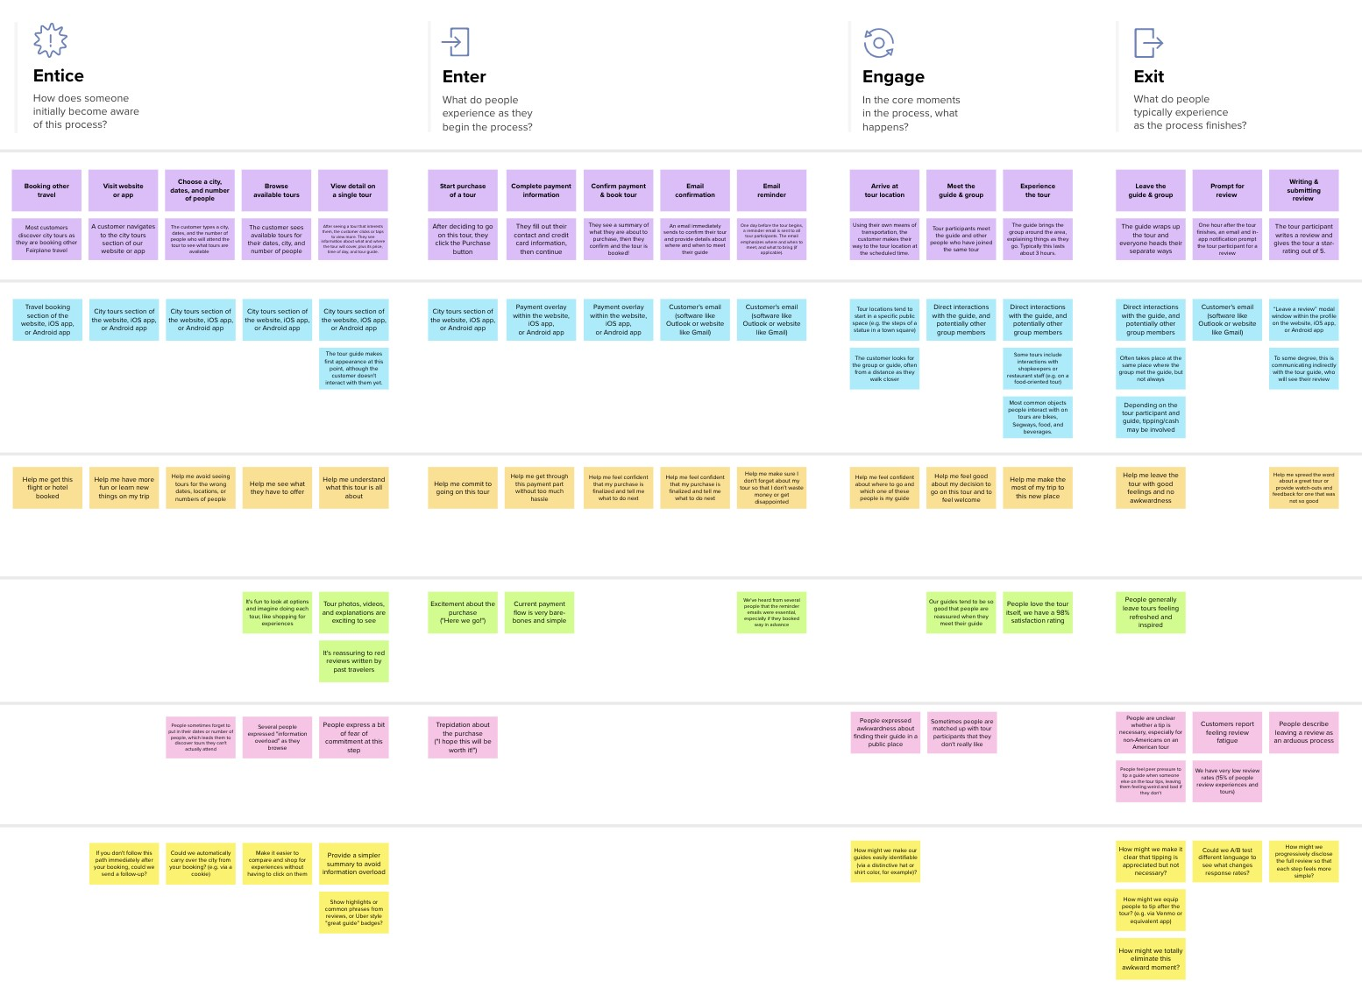

**Template**



[**Open example**](https://app.mural.co/template/f59f644b-b4b4-47b5-9ed6-3a8c71ceb612/896b31fe-5597-40ef-9b06-3811a1a45ace)